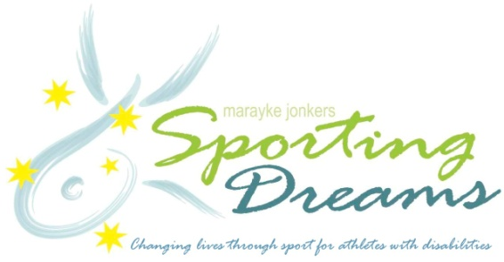

**2014 Sporting Dreams Grants**

**(Applications close 14 July 2014**)

Sporting Dreams is an annual grants program founded by triple Paralympian Marayke Jonkers in 2008 to assist Queensland athletes with a physical disability or vision impairment.The program is administered by Sporting Wheelies andDisabled Association, the peaksporting body in Queensland for people with a physical disability or vision impairment.

The aim of Sporting Dreams is to enable people with a disability to enjoy fun, fitness and personal development through sport and to achieve their sporting dreams - becoming role models for a fit and healthy lifestyle in the process. All funds distributed through the Sporting Dreams grants program are the result of fundraising efforts by Marayke throughout the year. To date, the program has benefited 97 athletes from a range of sports.

**Who is eligible?**

Sporting Dreams grants are open tobeginner and developing athletes with a physical disability or vision impairment who live in Queensland. There is no age restriction.

There are two levels of grants:

* Introductory grants of $250 for beginner athletes or athletes in their first year of competition
* Development grants of $500 for established athletes

Grants may be used for any sports-related expenses including equipment, competition entry fees, travel to competitions, uniform, club memberships etc.

**How do I apply and when will I know if I’ve been successful?**

Eligible athletes are invited to apply for a 2014 Sporting Dreams grant by filling out the official application form on the Sporting Dreams website [www.sportingdreams.org](http://www.sportingdreams.org/). Contact Ben MacFie at Sporting Wheelies and Disabled Association on (07) 3253 3333 with any questions regarding the application process.

Athletes will be notified whether their application has been successful in late July or early August 2014. Grants will be presented at an official awards ceremony in September/October 2014.

**Tips for completing the application**

* All applications must be made on the official application form.
* Ensure the applicant meets the selection criteria listed on the application form.
* The selection panel will assess each application based on the information provided.
* Be specific when responding to questions. For example “I will spend the grant money buying a new shooting jacket which will cost $300” is better than “I will spend the grant money on training and competition.” Explaining how the shooting jacket will enhance your performance will also improve the quality of your application.

**Application checklist - before submitting your application, ensure it contains:**

1. Completed application form
2. Responses to all questions are typed into the application form or attached
3. A high-resolution or hardcopy photograph is attached
4. Comments from coach/parents/managers included (you may attach a separate letter from your coach etc. if needed)

**Key dates**

2014 Sporting Dream grant applications open: 10 June 2014

Applications close: 14 July 2014

**FREQUENTLY ASKED QUESTIONS**

**What can I spend my grant money on?**

Anything that will improve your sporting performance. Some examples include: equipment such as a wheelchair basketball chair, equipment maintenance, coaching fees, uniform costs, travel to competition, a carer to help you at training, transport to and from training, entry fees for events, and gym or personal trainer fees.

**Why are grants only available once per year?**

Sporting Dreams is a small grants fund made possible by fundraising efforts by Marayke each year. The total funding amount raised at the time that grant applications close will determine the number and type of Sporting Dreams grants awarded. By awarding grants once per year, all athletes have an equal chance to apply and receive grants from the available funds, based on the quality of their application.

**I have an event next month. Can you help me to pay for my travel expenses?**

Sporting Dreams grants are awarded annually and not available ‘on request’. Grants are made to help with your expenses over the upcoming year. We encourage you to apply for the 2014 funding round. Remember - part of being an elite athlete is planning your key competitions for the year, and applying for funding in advance.

**What is the difference between an introductory and a development grant?**

Introductory grants are for athletes who are new to their sport, in the first year of competition or still at a beginner level in their sport. Development grants are for established athletes.

**I live outside Queensland. Can I apply?**

Unfortunately, grants are for Queensland residents only.

**Can I apply every year?**

Development athletes are eligible to apply every second year. Introductory athletes may apply for a development grant the year after receiving an introductory grant.

**Who assesses the grant applications?**

The selection panel comprises Marayke Jonkers, a representative from Sporting Wheelies and Disabled Association and at least one additional panel member.

**Why do I need to include a photo with my application?**

Photos of successful grant applicants will be used in the award ceremony programme, audio-visual presentations, the Sporting Dreams website, social media and other promotions. The photo ideally will show you competing or wearing sports gear, but a simple headshot is fine.

**What is the Sporting Dreams awards ceremony?**

The awards ceremony is an opportunity for successful grant applicants to meet and celebrate their achievements with family and supporters, and receive their grant from Sporting Dreams founder and MC, Marayke Jonkers. You are encouraged to say a few words, with help from Marayke, and thank your supporters. Successful applicants will receive full details about the awards ceremony, including venue and date, closer to the event.

If you cannot attend the awards ceremony, a representative can receive the grant on your behalf or arrangements can be made to send your grant and certificate to you after the event.

**For more information about 2014 Sporting Dreams grant applications, contact Ben MacFie at Sporting Wheelies and Disabled Association on (07) 3253 3333.**